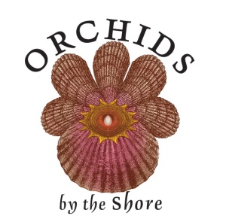
Galveston Bay Orchid Society
“Orchids by the Shore” Show & Sale
Also SWROGA 2014 Fall Meetings
September 5-7, 2014
South Shore Harbour Resort & Conference Center
2500 South Shore Blvd, League City, TX 77573

Exhibit Request Form

___________________________________________________________________
Name of Exhibitor

___________________________________________________________________
Person in Charge of Exhibit

Address _____________________________________________________________

City __________________________________ State ______
Phone ________________________________
E-mail _____________________________________________________________

Type Exhibit Requested:

50 sq. ft. floor exhibit ____ 25 sq. ft. floor exhibit _____ table-top exhibit _____

Need electricity ____________________________________________________

Other requests: ____________________________________________________

Mail form ASAP to:
Larry Baker
3733 Meadowlark Way
Pearland, TX 77584
Phone: (281) 412-4466
Email: lirvinb@yahoo.com

